PRECISION NUTRITION PIPELINE

- Overview
- CRISP-DM framework for Growth Analysis
NO | PROCESS | DESCRIPTION
1 | Project Understanding
 | Objective | Research Question:  Are maternal dietary and socioeconomic factors associated with early childhood growth trajectories, as defined by BMI-for-age z scores (zBMI)-based cluster patterns at 24 month of age?  Population:  Children aged 24 months (n = 300) in the study cohort with available growth and maternal characteristics.  Exposures:  Maternal ultra-processed food (UPF) consumption, total energy intake (kcal), and household income.  Outcome:  zBMI trajectory clusters among children.
 | 1a. What exactly is the problem, the expected benefits? | Early childhood represents a critical window for growth and metabolic programming, during which nutritional adequacy exerts influences on long-term health trajectories. Inadequate or excess nutrition during this period is associated with malnutrition or accelerated risks in metabolic diseases later in life. Identifying factors associated with early-life growth patterns could help identify children at risk of adverse health outcomes and inform the development of public health and clinical guidelines. Growth trajectory assessments is therefore an important analytic tool. However, the heterogeneity of early childhood growth patterns often limits the ability to detect meaningful subgroups, and a data-driven framework capable of capturing this heterogeneity is needed.  Maternal factors, including dietary quality, energy intake, and socioeconomic status, have been shown to affect infant growth. However, the degree to which these factors shape the children’s growth trajectories in the first 24 months of life remains incompletely understood. The proposed approach examines the maternal factors, including UPF consumption, total energy intake, and household income, as modifiable and measurable predictors of heterogeneous growth patterns. By grouping children according to similar growth patterns, our framework supports the targeted disease prevention strategies and promote healthy dietary practices during gestation and early life.  Expected Benefits:  - Understanding maternal exposures to child growth profiles: Examining trajectory clusters of maternal dietary (UPF intake, total energy intake) and socioeconomic (household income) factors will reveal which exposures are implicated in shaping early child growth, providing basis for targeted intervention  - Identifying grow heterogeneity: By applying trajectory clustering to longitudinal zBMI data, standardized for age and sex according to WHO Child Growth Standards, we can identify subgroups of children with meaningful distinct growth patterns at 24 months of life.  - Identifying at-risk subgroups: Clustering zBMI trajectories will enable the early detection of children who may be on adverse growth paths early, aiding timely clinical and public health intervention.  - Informing precision nutrition strategies: Findings from this project can support the development of precision nutrition approaches tailored to the specific maternal exposure profiles that are most associated with high-risk growth trajectory clusters.
 | 1b. How would a solution look like? | Children will be clustered based on their zBMI scores at 24 months, and these clusters will be used to determine whether maternal UPF intake, total energy intake, and household income, are associated with zBMI categories.  Outputs:  - Distinct child growth clusters: A set of distinct child clusters, each characterized by key variables: maternal UPF intake, total energy intake, and household income.  - A visual summary: A dendrogram that clearly shows cluster differences in zBMI and associated maternal exposures.  - Interpretation for each cluster: For example, a cluster with high UPF consumption + high total energy intake + low household income.  Each cluster will be clinically interpreted. From these analyses, we may be able to extract meaningful information regarding which maternal factors are strongly associated with adverse growth trajectories and the directionality of those associations. We may then use this evidence to establish tailored, early-life interventions.
 | 1c. What is known about the domain? | Early-life growth trajectories are known predictors of later obesity and metabolic disease risk, and maternal nutrition and socioeconomic conditions have been shown to influence early childhood growth and development.  zBMI based on WHO Child Growth Standards are internationally accepted tool for classifying nutritional status in children under 5.
2 | Data Understanding
 | 2a. What data do we have available? | Maternal dietary factors:  - Energy intake (kcal) – continuous  - Fiber intake (g) – continuous  - Protein intake (g) – continuous  - Ultra-processed score – continuous  - Dietary pattern score – continuous  Microbiome factors:  - Firmicutes : Bacteroidetes ratio – continuous  - Shannon diversity – continuous  - SCFA index – continuous  Socioeconomic factors:  - Household income – continuous  - Maternal education (years) – ordinal  Maternal health factors:  - Maternal BMI (kg/m²) – continuous  - Gestational age (weeks) – continuous  Clinical biomarkers:  - Fasting glucose (mmol/L) – continuous  - C-reactive protein (CRP) (mg/L) – continuous  - Alanine aminotransferase (ALT) (U/L) – continuous  Child growth variables:  - Age at 24 months (months) – categorical  - Sex – categorical  - Weight at 0 (birth), 6, 12, and 24 months (kg) – continuous  - Length at 0 (birth), 6, 12, and 24 months (cm) – continuous  - BMI & BMI-for-age z-scores (zBMI) at 24 months – continuous  - Stunted status at 24 months – categorical
 | 2b. Is the data relevant to the problem? | Yes, the provided dataset includes 30 variables representing maternal dietary factors, socioeconomic factors, clinical biomarkers, and gut microbiome, which are possible determinants of growth and metabolic health and are being tested for their association with the outcome of interest (zBMI at 24 months).
 | 2c. Is it valid? Does it reflect our expectations? | The data leveraged is commonly used for clinical and nutritional measures.  However, several potential data quality issues exist, including:  - Missing data  - Implausible age values  - Outliers in zBMI and clinical biomarkers  - Data entry error  The data will need to be evaluated using exploratory analyses (histograms, boxplots, and scatterplots) to assess the distribution of variables, detect outliers, and evaluate if the values reflect realistic biological values. The missingness pattern should be assessed to guide imputation.
 | 2d. Is the data quality, quantity, recency sufficient? | Quantity: The dataset contains 300 observations across 30 variables, providing a reasonable sample for exploratory clustering. However, there is a possibility of clusters with small numbers (e.g. n <30) which underpowered for biological interpretation.  Quality: The dataset appears sufficient for exploratory growth analysis, although there are intentional imperfections (e.g., missing data, implausible values, biological outliers) that will need to be assessed and addressed in the statistical model to improve the reliability of the data.  Recency: Not applicable (mock precision nutrition cohort)
3 | Data Preparation
 | 3a. Which data should we concentrate on? | Maternal dietary factors:  - Ultra-processed score  - Energy intake (kcal)  Socioeconomic factors:  - Household income  Child growth variables:  - BMI-for-age z-scores (zBMI) at 24 months
 | 3b. How is the data best transformed for modelling? | The data will undergo several transformations, including:  Handling skewed data  - If any of the variables are found to be non-normally distributed, appropriate transformations will be applied (e.g., log-transforming data) to try to approximate normality to improve model stability  Handling categorical data  - Categorical data was already transformed into a usable binary system for modelling.  Transforming BMI data  - BMI data was z-score transformed, possibly using the LMS (Lambda-Mu-Sigma) method, adjusting for sex and age to provide a standardized measure to compare to growth charts
 | 3c. How may we increase the data quality? | Data quality can be improved through:  - Identifying and evaluating statistical outliers  Growth data cleaning  - Removing implausible age values (e.g., negative values)  - Applying WHO growth cut-offs to identify biologically implausible zBMI values (values that fall outside of WHO recommendations, 5 $≥$ zBMI $≤$ -5, will be flagged and removed from the dataset). We set our threshold as 5 $≥$ zBMI $≤$ -5, as this has previously been defined as a threshold for data cleaning of impossible zBMI measurements (PMID: 15069916).  - Treat impossible CRP values (negative) and will be recode as missing and applied for imputation or exclude.  Missing data  - Data will be carefully assessed to determine if the values are missing completely at random, missing at random, or missing not at random  - Any missing values will be assessed to determine if it is more appropriate to remove the entire record (deletion) or replace missing values using estimates (imputation) either by using mean/median imputation (replacing the missing values with the mean of the column), mode imputation (replacing the missing value with the most common, i.e., mode, value of the column) or using K-Nearest Neighbors (using KNN algorithm to find similar records and using their values to fill in missing data)  - If too many values are missing from a column, the variable may be omitted from analysis entirely
4 | Modelling
 | 4a. What kind of model architecture suits the problem best? | Growth trajectory analysis will be used to identify groups of children (i.e., clusters) with similar zBMI trajectory patterns at timepoint 24 months.  An unsupervised clustering is most appropriate, given the goal of identifying naturally occurring subgroups of children based on their zBMI trajectories and associated variables.  Distance metrics will measure similarity between individuals.
 | 4b. What is the best technique/ method to get the model? | Clustering approaches such as k-means or hierarchical clustering will be used to identify distinct trajectory groups.  - K – Means: assign each child to the nearest centroid.  - Hierarchical clustering: build a dendogram to explore natural groupings without a fixed k.  The ideal number of clusters will be identified using statistical methods, such as the elbow method or silhouette score. Regression models will then evaluate associations between maternal factors and trajectory membership.
 | 4c. How good does the model perform technically? | Model performance will be evaluated using cluster validation metrics such as silhouette scores and examination of regression model assumptions.
5 | Evaluation
 | 5a. How good is the model in terms of project requirements? | The model will be evaluated based on its ability to identify biologically meaningful growth patterns and whether maternal factors significantly explain differences in trajectory groups.  Evaluation of the clustering approach will be assessed by:  - Cluster tendency analysis (Hopkins statistic and PCA)  - Silhouette score  - Within-cluster variance  - Visualization of trajectory patterns  Evaluation of the regression models will be assessed by:  - R²  - Residual diagnostics  - Statistical significance of predictors (i.e., maternal dietary, socioeconomic, and clinical factors)
 | 5b. What have we learned from the project? | The analysis will provide insight into how maternal diet, socioeconomic conditions, maternal health, and gut microbiome may influence early childhood growth trajectories. Identifying these associations may help inform targeted early-life nutrition interventions.  Precision nutrition insights from integrating multiple data domains (diet, gut microbiome, clinical, and socioeconomic) rather than single variables alone.  Reproducibility is essential for transparent science and further research.
6 | Deployment
 | 6a. How is the model best deployed? | The model could be used as a screening tool to identify maternal dietary, socioeconomic, clinical factors, and gut microbiome associated with unfavorable child growth trajectories. In clinical or public health settings, such information could help guide targeted nutritional counselling during pregnancy and early childhood to support healthy growth patterns. Ethical considerations for its implementation will also be made, particularly if any socioeconomic factors are found to be strongly associated with zBMI trajectories.  The reproducible R pipeline in GitHub ensures any clinical site could re-run the same pipeline.
 | 6b. How do we know that the model is still valid? | Model validity would require testing the model on a new dataset to determine if similar growth patterns and associations are observed in a different population (i.e., using a test dataset that is independent of the training dataset).  However, some limitations will exist, including potential residual confounding, measurement error in dietary reporting, and limited generalizability beyond the study cohort.  Data pipeline integrity will ensure that any changes to WHO cut-off parameters or imputation technique are tracked, reproducible, and reviewable by collaborators and the instructor.
7 | What is your goal?
8 | Which is the population/cohort that  you are using?
9 | Data structure/properties:
10 | Gold Standard:

- Dataset description
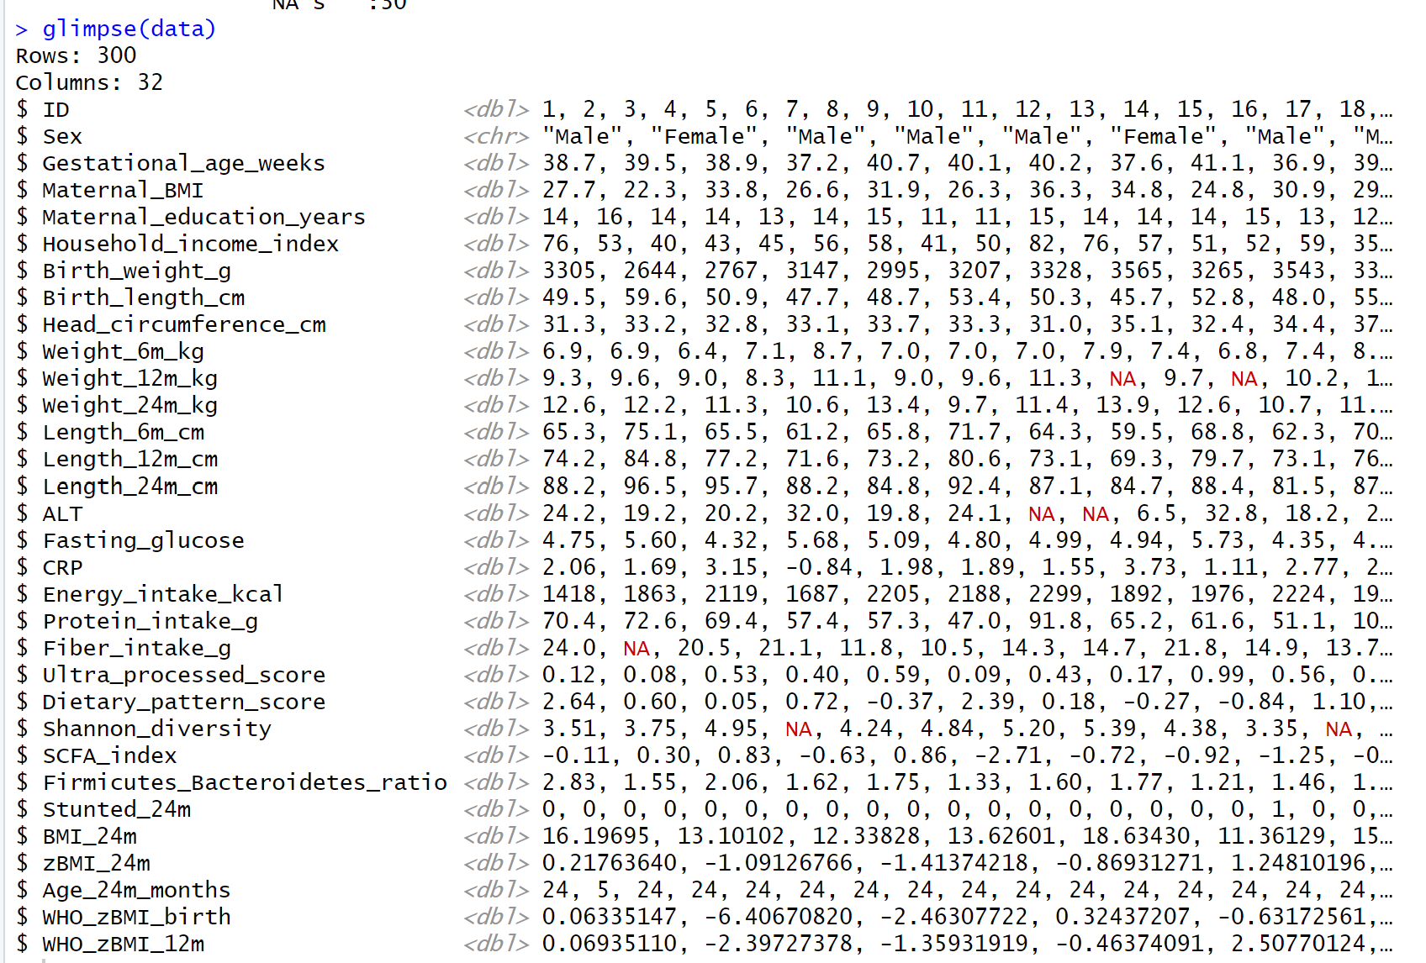
The dataset contains of 31 values with 300 participants.
Missing summary:
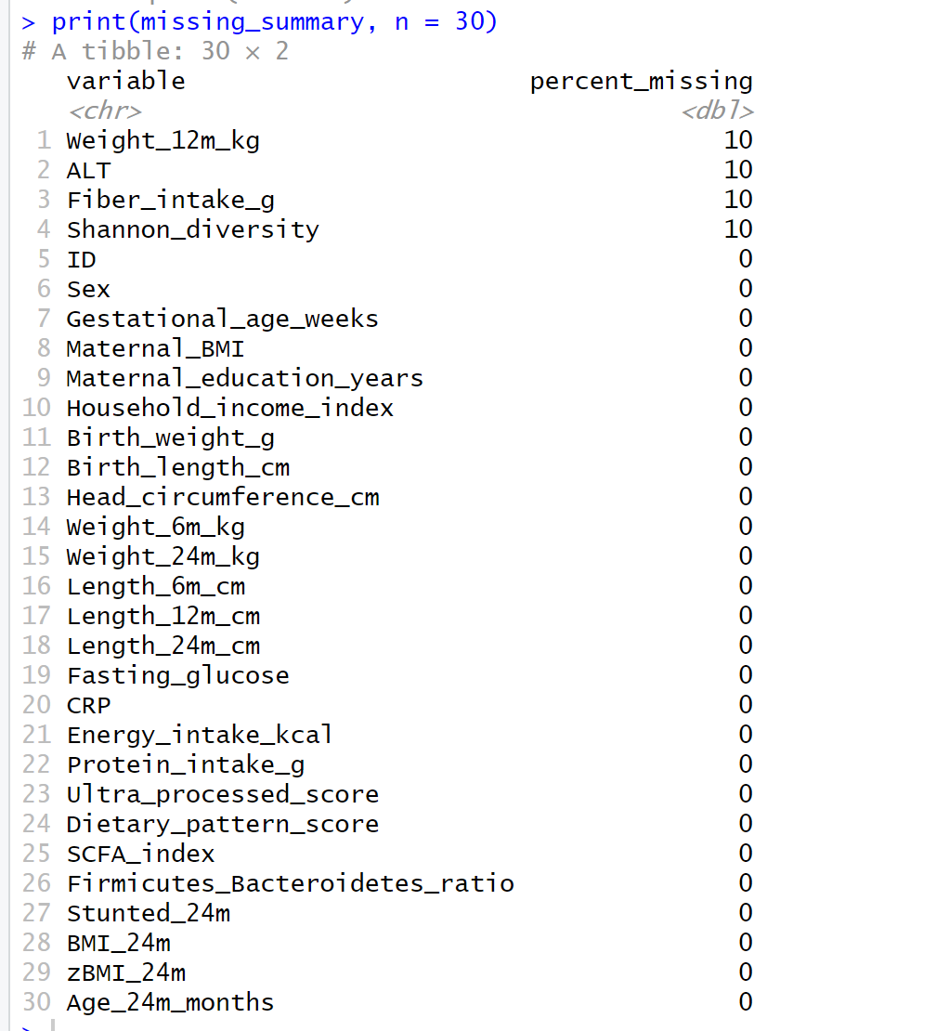

Missingness Plot:
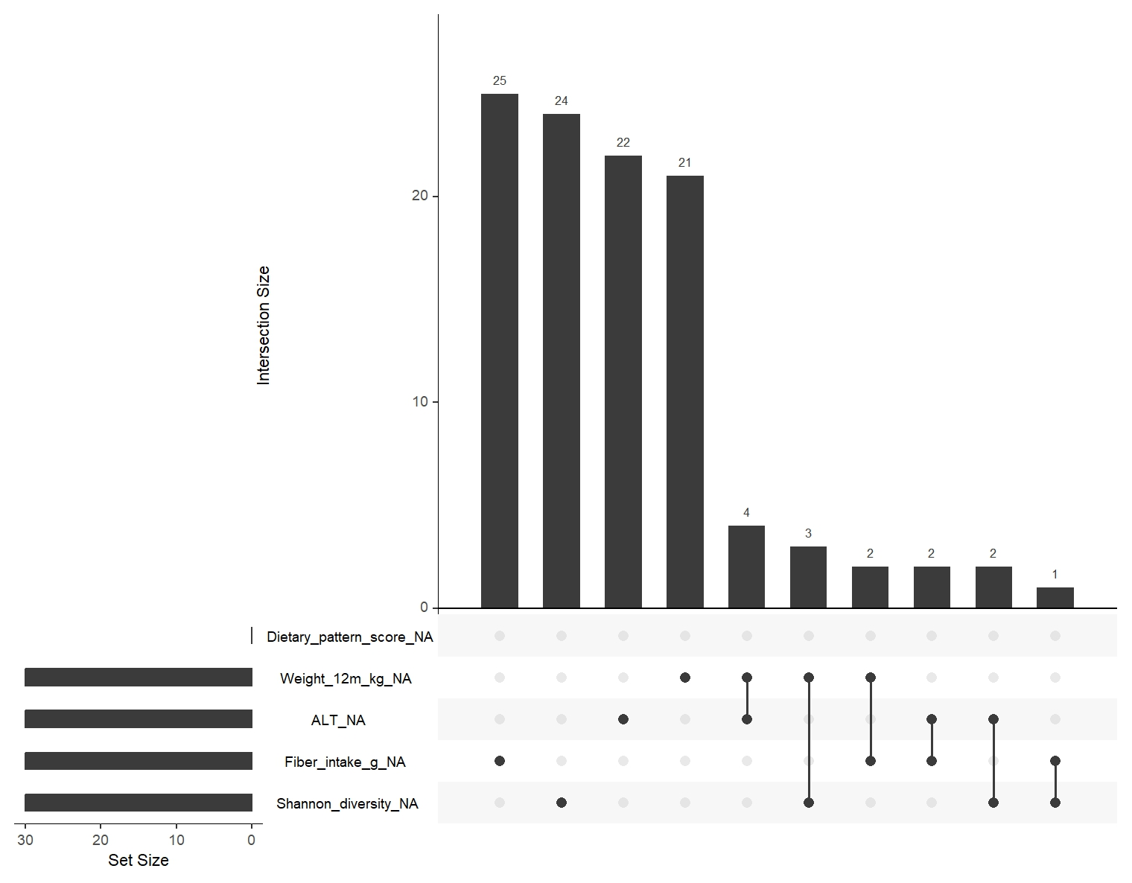

This plot shows how many observations share the same missingness pattern:
Bar | Missing Pattern | Count
First (25) | Missing in Fiber intake | 25
Second (24) | Missing in Shannon Diversity | 24
Third (22) | Missing in ALT | 22
Fourth (21) | Missing in Weight in 12 months | 21
Fifth (4) | Missing in Weight 12 months and ALT altogether | 4
Sixth (3) | Missing in Weight 12 months and Shannon Diversity | 3
Seventh (2) | Missing in Weight 12 months and Fiber intake | 2
Eight (2) | Missing in ALT and Fiber intake | 2
Ninth (2) | Missing in ALT and Shannon Diversity | 2
Tenth (1) | Missing in Fiber intake and Shannon Diversity | 1

Missingness was handling with Imputation using MICE method for all five variables which has 10% missing data (n = 30).
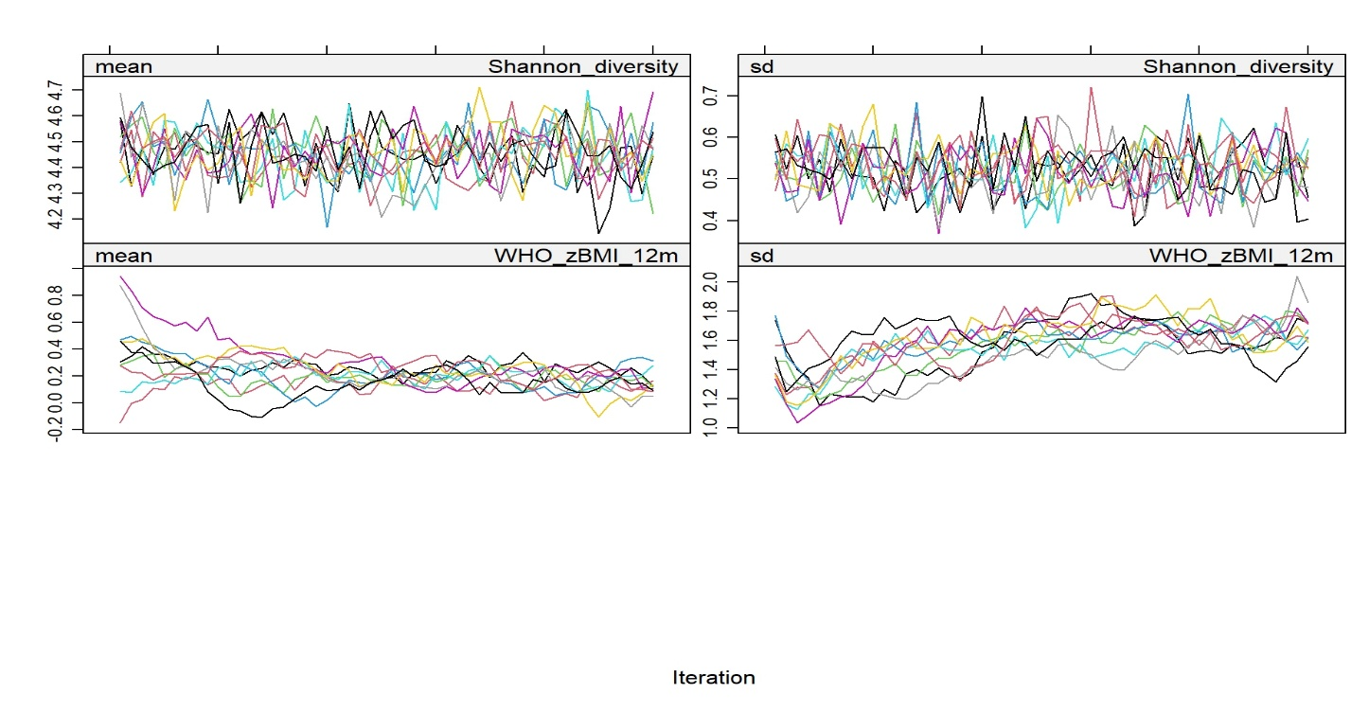
Plot Imputation
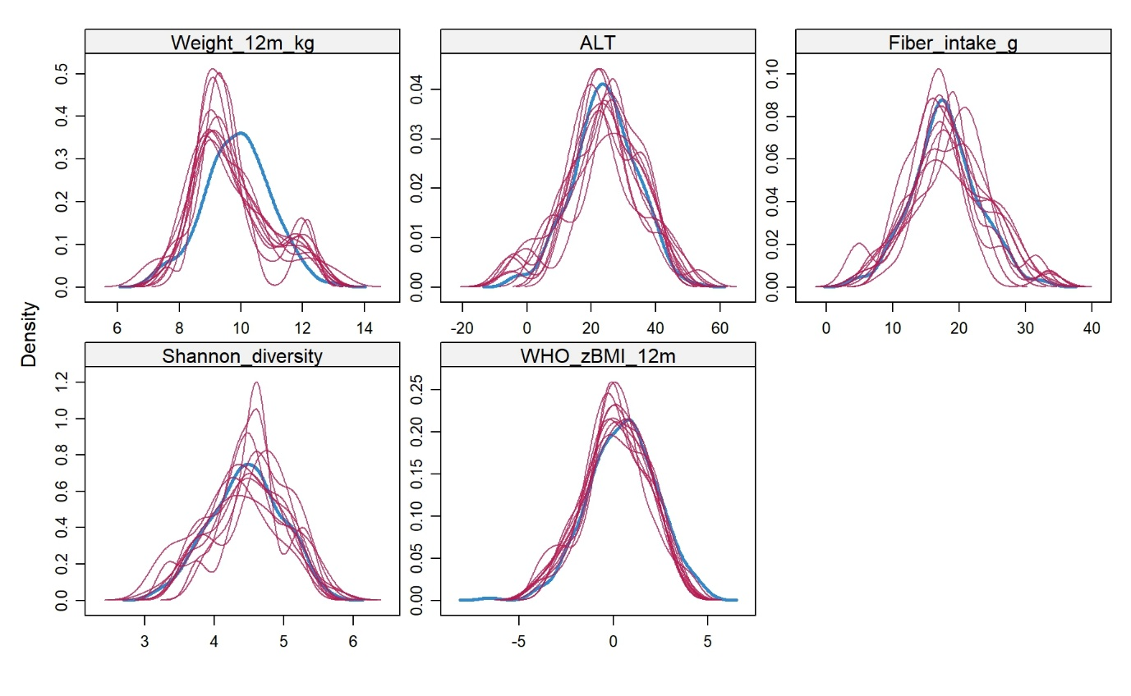
Density Plot
Density Plot shows all variables have been imputed. The imputation in Weight_12m_kg influenced the plot for WHO_zBMI_12m. Because BMI = weight divided by (length)²
- Cleaning decisions
- Clean Growth Data using WHO cut-offs
Applying WHO growth cut-offs to identify biologically implausible zBMI values (values that fall outside of WHO recommendations, 5 $≥$ zBMI $≤$ -5, will be flagged and removed from the dataset). We set our threshold as 5 $≥$ zBMI $≤$ -5, as this has previously been defined as a threshold for data cleaning of impossible zBMI measurements
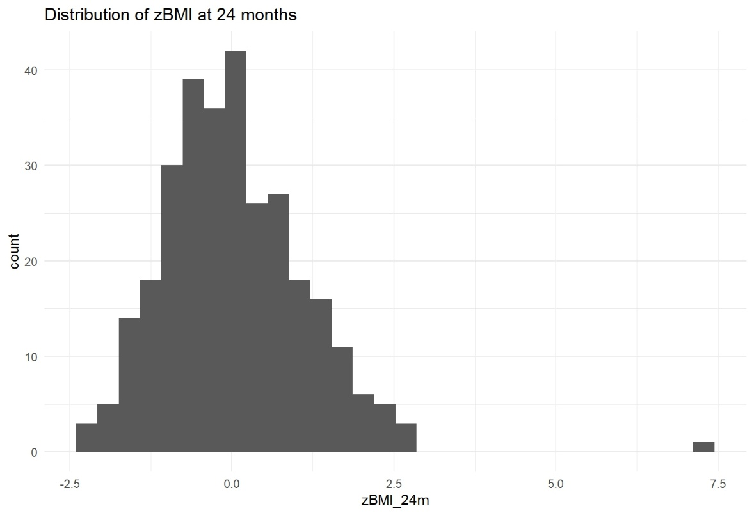
- Clean CRP
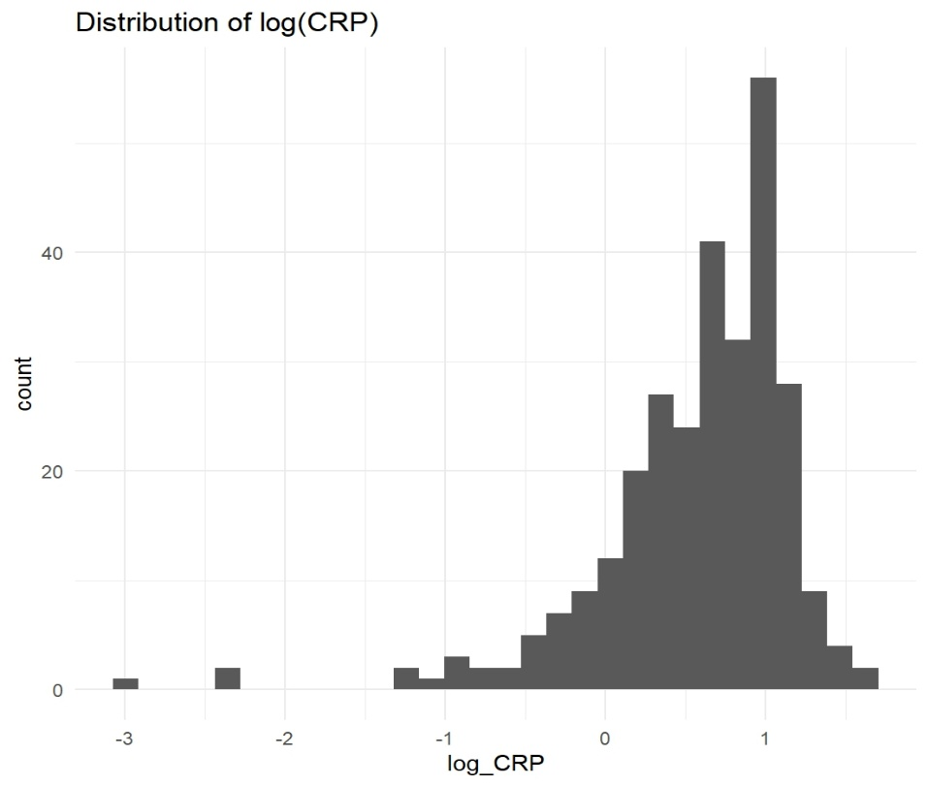
This bar graph shows right skew, so the CRP values are transformed using natural log (ln) to convert the skewed distribution into a more normal distribution (bell-shaped).
Log CRP is ideal for statistical models, including clustering, regression, correlation, and machine learning, where normality is assumed.

- Reproducible Instructions

